

Endeca
Training
Documentation

Mike McLaughlin
December, 2010

Endeca Fundamentals

What is Endeca?
Endeca is self described as "a search and business intelligence software company that helps people both find what they need and understand what they found." When we refer to Endeca, we are referring to version 5.1.4 of their Endeca Platform technology which we use to collect product related data, apply business rules, and respond to product related search and navigation requests from the various QVC systems with tailored product information.

There are currently six Endeca applications installed here at QVC.
usproduct | Legacy app that interacts with legacy nav servers and legacy US qvc.com site.  (outside the scope of this document)
refdoc | App that provides reference document information to CSOE reps.  (outside the scope of this document)
uswebproduct | App that includes all US product data that is available to sell (in-stock or waitlisted).  This app handles a great majority of the search and nav activity from the site.
usfullproduct | App that includes all US product data (in-stock, waitlisted, or sold-out).  This app is used to determine if an item is sold-out and by CSOE reps.
defullproduct | App that includes all DE product data (in-stock, waitlisted, or sold-out).  This app is used by the DE commerce based site.  While most of the information in this document could be applied to the DE site, it does not include any information specific to this site.
ukfullproduct | App that includes all UK product data (in-stock, waitlisted, or sold-out).  This app is used by the UK commerce based site.  While most of the information in this document could be applied to the DE site, it does not include any information specific to this site.

There are two sets of processing that we do with Endeca. We have a process that updates Endeca, and a separate process that accesses information from Endeca. In both cases, Endeca is mostly interacting with Commerce systems.

The following is a high level view of the whole process from source data to search results:

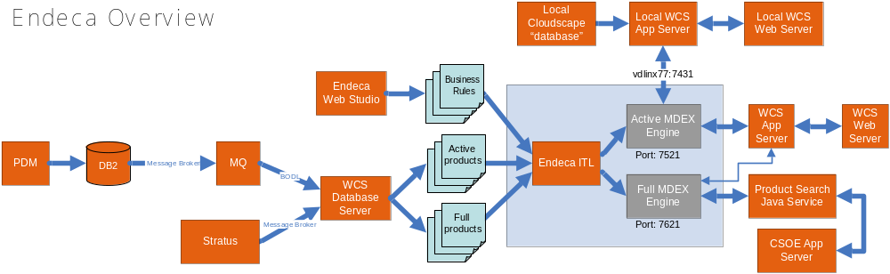

PDM to WCS Database Server
PDM, or Product Data Manager, is used to create, update, or destroy product information such as product attributes that is ultimately stored in DB2 tables. There is a message broker process that then reads the information from this database, and feeds a queue. RTPU, or Real Time Product Updates, then pulls the product information from the queue and stores it in the WCS Database server.

Other product related information, such as product availability, is maintained in Stratus. Therefore, a second RTPU process reads from Stratus and feeds that information into the WCS Database server.

WCS Database Server to Endeca
The data needs to get from the database server into Endeca in order to be used for search or navigation. Therefore, java based data extract code was created to extract the required data from the database, format it, and write the data out to flat files to be used by Endeca. This extract process is kicked off by control scripts which are scheduled via the cron. Once the files are created, the script conducts the transfer of these files to the Endeca ITL/Forge servers.

The following is a simplified diagram which depicts this action:

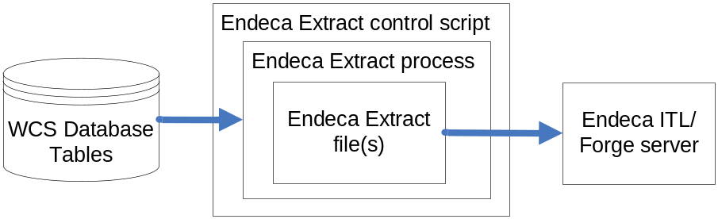

Endeca Update Processing
There are two types of Endeca servers that we use here. The Endeca ITL/Forge server is responsible for creating, updating, and transporting the search index while the Endeca MDEX/dgraph servers are responsible for responding to requests based on the content of the installed index. The Endeca index is a set of files that contain the product information and business rules in a highly optimized format for quick retrieval.

The cron is scheduled to periodically check for the existence of these extract files. Once if finds one or more of these files, it kicks off the update script. There are currently three different types of Endeca extracts and updates.

Baseline Extract/Update
The baseline extract/update completely rebuilds the index and clears out all previous partial updates. The baseline extract is currently scheduled to start at 3am every morning on the commerce database server, and takes about an hour to complete. On the Endeca server, there is a process looking for the baseline.done file every 10 minutes. Once the files have been transferred to the Endeca server, a baseline.done file is sent over which triggers the update process. This process uses the contents of these files to generate the new index and then sends it out to all dgraphs.

Part of the process to replace the search index on the dgraph requires that the dgraph refuse to respond to any search requests. This occurs during every baseline update, one group at a time, and lasts for about a minute each. During this process, if the load balancer recognizes that it is denying requests, it will put that dgraph into a "probe failed" state, making sure not to send any future updates to it until it recovers. The recovery process is monitored by a periodic health check. Once the health check sees that it is back up, it will again start sending traffic to this dgraph.

The following is a sample of the filenames created by the Endeca Baseline Extract process, along with the path that they are found on the Endeca ITL server:
/data/usfullproduct/data/incoming/Product.extract.full-2010-12-28_03-01-59.txt.gz
/data/usfullproduct/data/incoming/baseline.done
/data/usfullproduct/config/pipeline.dims/Facets.xml
/data/usfullproduct/config/pipeline.dims/FullHierarchy.xml

/data/uswebproduct/data/incoming/Product.extract.active-2010-12-28_03-01-59.txt.gz
/data/uswebproduct/data/incoming/baseline.done
/data/uswebproduct/config/pipeline.dims/Facets.xml
/data/uswebproduct/config/pipeline.dims/FullHierarchy.xml

Partial Extract/Update
There are two types of partial updates. The 15-minute partial extract/update will update every field of every record that has been flagged as needing to get updated. The ATS partial extract/update only updates the ATS (Available to Sell) flag of items that have been flagged as recently updated. This ATS extract runs every five minutes.

There is a flag in the DB2 database that indicates what records need to be sent to Endeca for partial update processing. For the 15-minute partials, if the "endeca_feed_ind" column in the xcatentry table is set to "1" for the product bean, then it is flagged. For the ATS partials, if the "endeca_feed_ind" column in the xskuinfo table is set to "1", then it is flagged.

Every partial extract also creates a .done version of the extract file to indicate to the Endeca server that the file is ready to be processed. The existence of a .done file is checked every five minutes on the Endeca server. Once a file has been found, then that partial update file goes through the Endeca partial update process which includes sending them to the index installed on the dgraphs. In order to apply the partial update, the dgraph needs to refuse requests until the processing is complete. This process usually takes about 30 seconds for each dgraph.

The following is a sample of the filenames created by the 15-minute Partial Extract process, along with the path that they are found on the Endeca ITL server:
/data/usfullproduct/data/partials/incoming/Partial.extract.full-2010-12-29_13-30-04.txt.gz
/data/usfullproduct/data/partials/incoming/Partial.extract.full-2010-12-29_13-30-04.txt.gz.done
/data/uswebproduct/data/partials/incoming/Partial.extract.active-2010-12-29_13-30-04.txt.gz
/data/uswebproduct/data/partials/incoming/Partial.extract.active-2010-12-29_13-30-04.txt.gz.done

The following is a sample of the filenames created by the ATS Partial Extract process, along with the path that they are found on the Endeca ITL server:
/data/usfullproduct/data/partials/incoming/Endeca_ATS-2010-12-29_13-30-04.txt.gz
/data/usfullproduct/data/partials/incoming/Endeca_ATS-2010-12-29_13-30-04.txt.gz.done
/data/uswebproduct/data/partials/incoming/Endeca_ATS-2010-12-29_13-30-04.txt.gz
/data/uswebproduct/data/partials/incoming/Endeca_ATS-2010-12-29_13-30-04.txt.gz.done

Web Studio Update
The Web Studio promote page was created to allow business users to migrate a new set of business rules ad-hoc to QA or production. The URL for this page in QA is:

http://wchlt12:9000/cgi-bin/usPromoteWebStudioChanges.cgi

The Promote button on this page executes a script on the back end ITL box named "promote_webstudio_changes.sh". This script essentially executes the Endeca command "ConfigUpdate" which pulls the latest Web Studio data and uploads that data to every dgraph. Since only one process can update a dgraph at one time, if a baseline or partial update is already in progress, then the web studio update must wait until that update is done before it can proceed.

The following diagram depicts these processes:
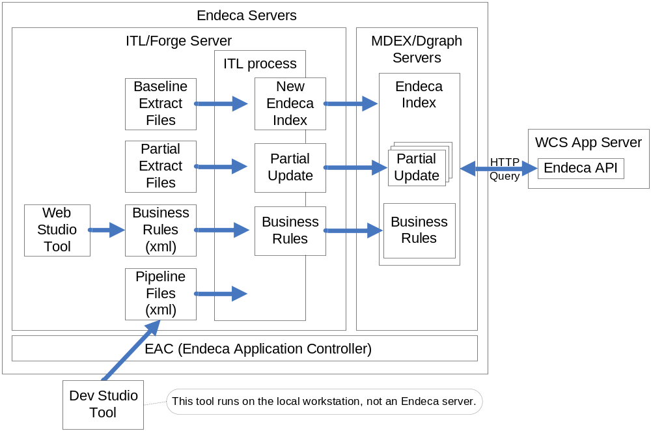

Endeca Provided Tools

Developer Studio (Dev Studio)
This tool, installed on the workstation as a Windows application, is an interface provided by Endeca that allows developers to make changes to the pipeline. The Endeca pipeline dictates how data are handled while getting processed by the baseline and partial updates. This tool, primarily used by developers, has more advanced abilities to it than the Web Studio tool, which is primarily used by the business team to make changes to business rules.

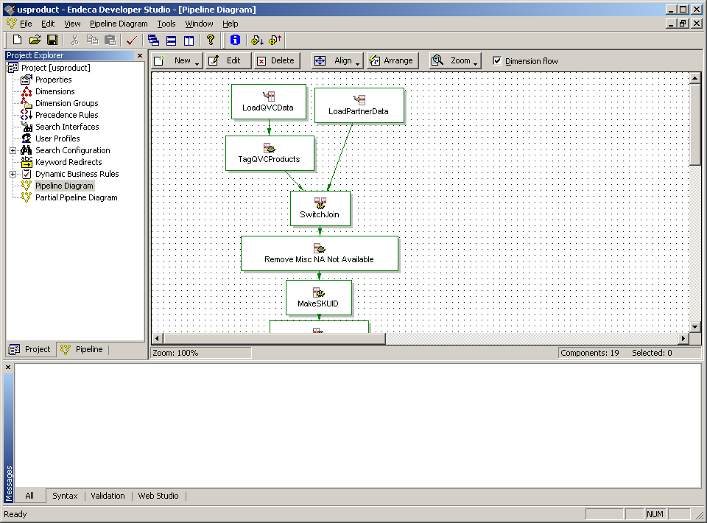

The installer can be found here: Q:\Interactive\Installers\Endeca\IAP 514\dstd514w2k.exe

The pipeline files can be transferred from the /data/<application>/config/pipeline directory of an Endeca ITL server to your local drive. It is sometimes best to zip the files first to prevent text formatting issues. From there, the dev studio tool can be used to load the pipeline files, allowing you to make changes to them. Once the changes are complete, you would then save your changes and close the tool. To activate the changes, transfer the new pipeline files to the /data/<application>/config/pipeline.staging directory of an Endeca ITL server and run the /data/<application>/control/update_pipeline.sh command. This tool will merge the new pipeline with other files and deposit the results into the /data/<application>/config/pipeline directory to be used by the next partial or baseline update.

Web Studio
This is a Java based interface provided by Endeca to allow our business team to read, create, update, and delete thesaurus entries, keyword redirects, stop words, and more. It currently runs on the same Endeca server as the Endeca staging environment. This allows the business team to see results from their changes before they go into production. This tool handles mostly different sets of data than the Dev Studio tool.

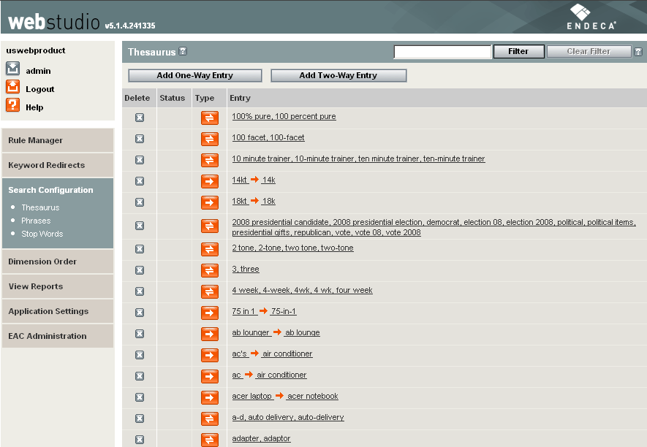

The following is the URL to the QA version of the Web Studio tool:
http://wchlt12.qvcdev.qvc.net:8888/login

Web Studio runs on the same web service as the EAC, so if one is not responding, then the other is likely not going to respond either.

MDEXPerf (aka ENEperf)
Endeca’s MDEXPerf is a lightweight multithreaded load driver that can apply load to an MDEX Engine. MDEXPerf outputs some statistical analysis and also outputs a log in a format compatible with Cheetah – Endeca’s forensic analysis utility. This tool is used to gauge real-time performance metrics via stress testing.

Cheetah
Cheetah reads one or more MDEX Engine logs and reports on the nature and performance of the queries recorded in those logs. This kind of analysis is called “forensic” because it reports on what actually happened in the past, instead of reporting on potential performance or capacity planning for the future. It should be run manually in order to debug performance problems. Cheetah is a Perl script that can be run using Perl 5.8.3, which is installed with the Endeca Information Access Platform.

This tool is used to measure past performance using existing request logs. It can currently be found in the development environment (vdlinx77) under /data/performance.

Endeca Technical Information

Server information by Environment
Test Environment | Extract server | Endeca ITL Server | Endeca dgraph server
Development | wcdd1000 | vdlinx77 | vdlinx77
Integration | wcid2000 | vilinx80 | vilinx80
QA | wchuqd2030 | wchlt12 | wchlt13
Staging | spkusd2040 | vslinx79 | vslinx79
Production - West Chester | wchupd2050 | wchlinx191 | wchlpmdx33-40
Production - Studio Park | spkupd2050 | spklinx192 | spklpmdx33-40

Endeca directory structure
All Endeca software is installed under the /data directory on the Endeca server under the standardized Endeca deployment template. The global Endeca software is then installed under /data/Endeca while the various Endeca app specific software is located under the /data/<app name> directory. For instance, all data and processes specific to the uswebproduct application is installed under /data/uswebproduct. The following table depicts the common Endeca directories that we may be referring to:

Directory | Contents
/data | All Endeca related software
/data/Endeca | All non-application specific Endeca software
/data/<appname> | All information related to that Endeca application
/data/<appname>/data | Where most data related to that app is found
/data/<appname>/config | Where configuration files are found
/data/<appname>/config/pipeline | Where the active pipeline files are found
/data/<appname>/config/script | Where key config files are found, like AppConfig.xml, dgraphImport.xml, and environment.properties
/data/<appname>/control | Where control scripts can be found
/data/<appname>/logs | Where various log files can be found

Common Endeca variables and their values:
ENDECA_CONF=/data/endeca/workspace
ENDECA_ROOT=/data/endeca/5.1.4/x86_64pc-linux

Troubleshooting
Most causes of issues can be found by tracing log files on the Endeca server.
The following are the locations of various log files:
ITL Server:
Baseline logs: /logs/baseline_update.out
Partial update logs: /logs/partial_update.out
Notifications: /logs/notifications

MDEX Server:
Dgraph request logs: /logs/dgraphs/<dgraph name>

All Endeca Servers:
Workspace logs: /data/endeca/workspace/logs

Dgraphs stats page URL:
http://<MDEX server>:7521/admin?op=stats
For example: http://wchlpmdx35.qvcdev.qvc.net:7521/admin?op=stats

Dgraph ping URL:
http://<MDEX server>:7521/admin?op=ping
For example: http://wchlpmdx35.qvcdev.qvc.net:7521/admin?op=ping

EAC Agent check
http:// <MDEX server>:8888/eac-agent/IDelegateServer?wsdl
For example: http://wchlpmdx35:8888/eac-agent/IDelegateServer?wsdl

Notifications
Alerts from /logs/notifications files:

Log File | Status | Status Message | Response
baselineNotifications | WARNING | No baseline.done file found. | Email to support team
baselineNotifications | WARNING | Unable to obtain baseline lock. | Email to support team
baselineNotifications | ERROR | An error occurred running Forge. | Notify service desk to contact on-call support
baselineNotifications | ERROR | An error occurred running Dgidx. | Notify service desk to contact on-call support
baselineNotifications | ERROR | Distribute index and apply process failed. | Notify service desk to contact on-call support
baselineNotifications | ERROR | An error occurred during archiving results from baseline process. | Email to support team
baselineNotifications | ERROR | An error occurred while cycling logserver. | Email to support team
baselineNotifications | ERROR | An error occurred during the baseline run. | Email to support team
baselineNotifications | ERROR | Baseline was not able to obtain MDEX interaction lock after 20 minutes. | Notify service desk to contact on-call support
partialNotifications | WARNING | No partial update data available. | Email to support team
partialNotifications | ERROR | Partial update forge process failed. | Notify service desk to contact on-call support
partialNotifications | ERROR | Partial updates could not be distributed and applied. | Notify service desk to contact on-call support
partialNotifications | ERROR | An error occurred during a partial update. | Email to support team
configNotifications | ERROR | Failed to get configuration from Web Studio. | Notify service desk to contact on-call support
configNotifications | ERROR | Failed to apply configuration to dgraphs. | Notify service desk to contact on-call support
configNotifications | ERROR | Was not able to obtain MDEX Interaction lock. | Notify service desk to contact on-call support

Locations of log files
Baseline Notifications: /logs/notifications/baselineNotifications.txt
Partial Notifications: /logs/notifications/partialNotifications.txt
Web Studio Config Notifications: /logs/notifications/configNotifications.txt

These are used to send alarms depicting the condition that trigged it.

Contacting Endeca Support

By Phone:
Call: (888) 363-3221

By Email:
Send email to: support@endeca.com
Include identifying information below in your initial email.
Emailed support requests are defaulted to priority 3.

By Website:
http://support.endeca.com
Log in to support site
Submit ticket

They assign a priority to service calls ranging from 1 to 4, where 1 is most critical.

Identifying information usually requested by Endeca:
Platform: IAP version 5.1.4, Deployment Template 2.3
OS: Red Hat Linux 4 – 64bit hardware/software
API: Java

Also, the following Endeca terms refer to the following files:
Control script » /config/script/AppConfig.xml
Override File » /config/script/environment.properties

EDeN
EDeN (Endeca Developer Network) is Endeca's support site.
You need to register an account on EDeN before you can use it very effectively.

URL: http://eden.endeca.com

